Experiment:7
Aim:
To write a Python program to implement Breadth-First Search (BFS) traversal of a graph.
Algorithm:
  - Start the program.
  - Represent the graph using an adjacency list.
  - Create an empty set called visited.
  - Insert the starting node into the queue.
  - Remove the first node from the queue.
  - If the node is not visited, print it and mark it as visited.
  - Add its unvisited neighbours to the queue.
  - Repeat until the queue becomes empty.
  - Stop
Code:
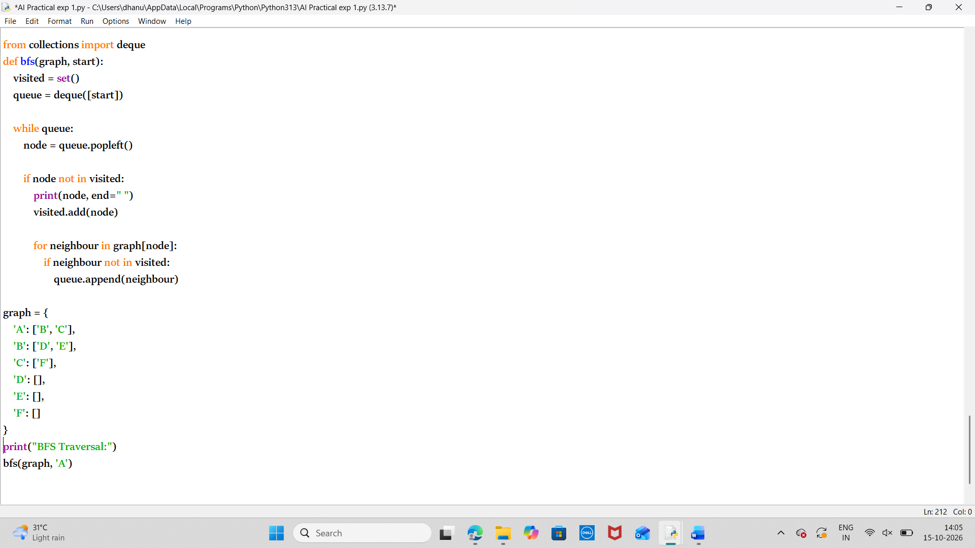
Output:
Result:
Thus the python program to solve the BFS is executed successfully.

